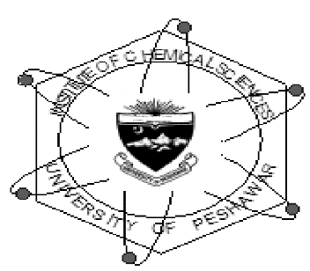
INSTITUTE OF CHEMICAL SCIENCES
UNIVERSITY OF PESHAWAR

Two Day National Workshop
on
Bioanalytical Techniques
(April 25-26, 2019)

Registration Form

- Name:__________________________________________________________________________________
- Father’s Name___________________________________________________________________________
- Class: __________________ Semester: __________________
Institution Address________________________________________________________________________________
_______________________________________________________________________________________________
Mailing Address: _________________________________________________________________________________
______________________________________________________________________________________________
Phone (Res): ________________________ Mobile: _____________________________
Fax: _______________________________ Email: ____________________________________________________

Signature: _____________________ Date: _____________________________

------------------------------------------------------------------------------------------------------------------------------------------------------------------
For office use only
Registration No: ____________ Date: _________________
Registration Fee: Rs. 500/-

Account Details:
Account Title: Alumni Department of Chemistry
Account Number: 15613-4
Bank: National Bank of Pakistan, Peshawar University Campus Branch (0388)

Note: Send this form at icsalumni@uop.edu.pk or submit it directly to in the Institute of office along with registration fee or alternatively deposit registration fee in the above account and submit/send receipt along with registration form.
For any query please dial 091-9216652 or send email at icsalumni@uop.edu.pk
Last date of registration is 19-04-2019.

------------------------------------------------------------------------------------------------------------------------------------------------------------------
Receipt

Mr./Ms._______________ has deposited Rs.________ dated __________as Registration fee for the two days national workshop on Bioanalytical techniques (25-26-2019).

Signature: ___________________
(Convener Registration Committee)

