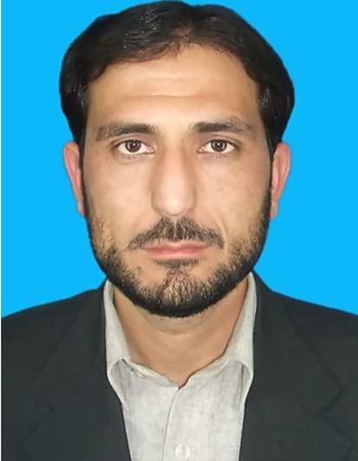  GHULAM FAROOQ KHAN  S/O Ghulam Nabi  Mailing Address: Quaid-e-Azam College of Commerce, University of Peshawar, KPK, Pakistan  Permanent Address: Village: Chail,P.O Kalpani Railway Station, Tehsil: Takht Bhai, District: Mardan  Ph# Office: 091-9218033  Cell# 0300-5034559  E-mail:  gfk_gfarooq@uop.edu.pk  gfk.gfarooq@gmail.com  Date of Birth: 30-12-1981  Domicile: Mardan, KP, Pakistan.  N.I.C. NO 16102-2266984-1  Religion: Islam  Marital: Married | OBJECTIVES:  My main objective is to work as a member of a team in a well-reputed and dynamic organization (Preferably Academia and Research), where I can broaden my horizons by complementing my theoretical knowledge through practical experience/Research.  An organization that provides me with the opportunity to apply my theoretical knowledge and technical skills, to produce satisfying, innovative and successful solutions to problems that may be faced  EDUCATIONAL QUALIFICATION:  Additional Qualification:  1-MSc. Economics ( University of Peshawar)  2-Additional Specialization in Finance (VU Pakistan)  PROJECTS:  Internship Report on Accountant General Office  EXPERIENCE:  1- Serving as Lecturer in Accounting (Regular) at Quaid-e-Azam College of Commerce, University of Peshawar since October 04, 2016 till date.  2- Served as Lecturer in Accounting (Contract) at QACC, University of Peshawar (i.e April, 30th, 2012 till October 04,2016)  3- Worked as Coordinator cum lecturer at Qurtaba University Of Sciences & IT Peshawar (i.e. April ,04, 2009 till April, 30th, 2009  4-Internship in the Office of Accountant General KPK.  ADDITIONAL SKILLS:  Good Communication Skills.  Firm grip on M.S Office, Compute-Based Accounting, Peach Tree, Quickbook, Talley  Fluency in English, Urdu, Pashto  INTERESTS:  Reading Books, News Papers and taking part in Debates & Group Discussions.
  Qualification | BOARD/UNIVERSITY
  M Phil (Mgt. Sc.) | Qurtaba University of Science and IT, Peshawar Campus
  M.Com(One Year) | University of Peshawar
  B.Com(Hons) | University of Peshawar
  B.Com | University of Peshawar
  F.Sc | B.I.S.E , Peshawar
  Metric | B.I.S.E , Peshawar

