CURRICULUM VITAE
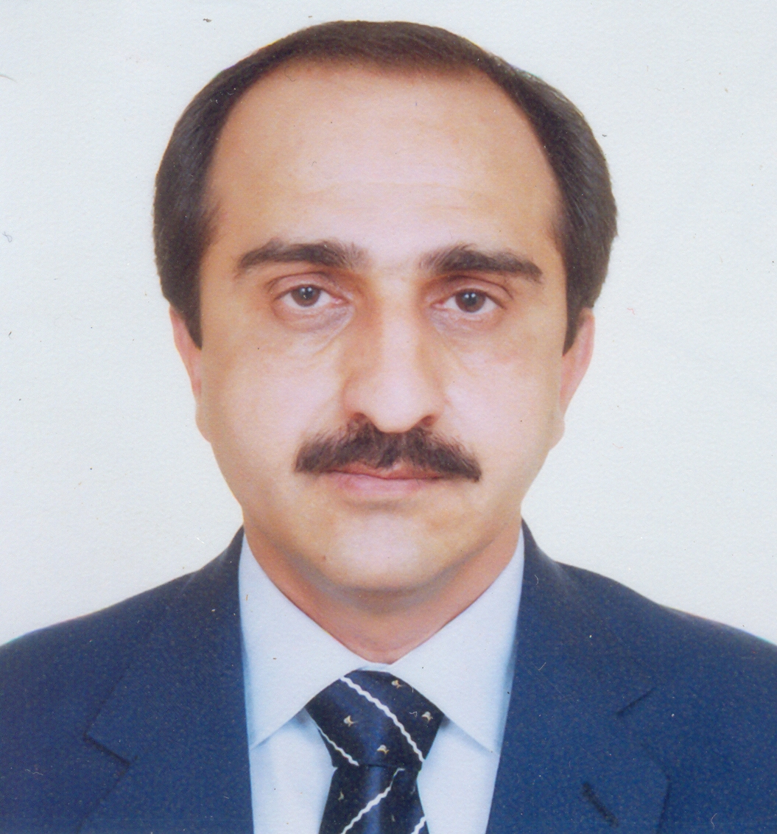
- Name: Javed Iqbal

- Date of Birth: October 12, 1968

- Educational Qualification
- Ph. D. Area Study Centre for Russia, China and Central Asia, University of Peshawar, Khyber Pakhtunkhwa, Pakistan, dissertation on Khyber Pass: Geography, People and History
- MA History (Gold Medalist), Department of History, University of Peshawar, Khyber Pakhtunkhwa, Pakistan

Academic Record
Degree/ Certificate | Session | Institution | Board/ University | Main Subjects
Ph. D | 2008 | Area Study Center for Russia, China and Central Asia | University of Peshawar | Central Asian Studies (History)
Master of Arts  (Gold Medalist) | 1989-90 | Department of History | University of Peshawar | History
Bachelor of Arts | 1988 | Edwardes College Peshawar | University of Peshawar | History, Political Science
Higher Secondary School Certificate | 1986 | Edwardes College Peshawar | Board of Intermediate & Secondary Education Peshawar | History, Islamic Studies, Pashto
Secondary School Certificate | 1984 | Private | Board of Intermediate & Secondary Education Peshawar | General Science, Mathematics, Pashto

- Current Occupation/Designation
Professor (BPS 21) &
Chairman
Department of History
University of Peshawar

- Languages: English, Urdu, Pashto
- Distinctions
- Gold Medal and First Class First Position in MA History Examination conducted by the Department of History, University of Peshawar under Semester System
- Winner of Sir Stevenson Runciman Award for securing first position in MA Previous Examination
- College Color for securing First Position in Internal Examinations for Intermediate part I and Part II, and BA part I and part II at Edwardes College Peshawar

- Student Life Co-Curricular Contributions
- Joint Secretary of Pashto Literary Society, Edwardes College Peshawar (1984-86)
- Chief Organizer of Pashto Literary Society, Edwardes College Peshawar (1986-88)

7. Professional Experience
- More than twenty (20) years teaching and research experience at the Department of History, University of Peshawar
- About 8 years Post Ph. D. experience
- Supervision of internal Semester Examinations and Results as Controller of Examinations in the Department of History, University of Peshawar
- In Charge Student Affairs, Department of History, University of Peshawar
- About one year experience as Staff Proctor in the University of Peshawar
- About three years experience as Broadcaster/ Senior Anchorperson of Sada-ye-Khyber Pakhtunkhwa, a programme broadcasted by Radio Pakistan Peshawar on National Broadcasting Service (NBS)
- Member Board of Studies in the Subject of History, University of Peshawar
- Member Board of Studies in the Subject of International Relations, University of Peshawar
- On the Panel of Khyber Pakhtunkhwa Textbook Board Writers of Social Studies and History Textbooks
- Member of National Curriculum Revision Committee in the subject of History, Higher Education Commission Islamabad
- Member of the Federal Public Service Commission Curriculum Revision Committee for the subjects of History
- Acting Chairman, Department of History, University of Peshawar, September 2010 to October 2012

8. Membership of Professional Associations
Member and Elected Joint Secretary of Peshawar University Teachers’ Association (PUTA), 2001-2002

9. Analysis of Relevant Experience
I have been teaching History of Muslim Freedom Movement in India and History of the United States for the last 20 years. History as a subject cannot be isolated and separated from any other discipline of knowledge. Even science and technology have got their own history and therefore cannot be completely dissociated from the subject in which I specialize. However, I believe my services can be utilized in an effective manner in the fields of culture, tourism, education, information and broadcasting, archives and museums, and also as cultural attaché at Pakistani Missions and Embassies abroad, particularly in India and United States. Pakistani Foreign Missions in different countries must have at least one historian, fully conversant with the history of that country because only a historian can give us a complete and accurate analysis of the national character, collective psychology and future aspirations of a nation in the light of their history.

- Publications: Articles
- “Maulana Abul Kalam Azad: A Reflection on His Political Status and Views about the Creation of Pakistan”, The Journal of Humanities and Social Sciences (Faculty of Arts and Humanities, University of Peshawar) Vol. V, No. 1, March 1997, pp. 84:98
- “Construction of Roads and Railways in the Khyber Pass during the British Period: A Positive Side-effect of British Colonial Rule”, in Central Asia, A Journal of Area Study Centre (Russia, China and Central Asia), University of Peshawar, No. 61, Winter 2007, pp. 161:172.
- “The Geo-Strategic Importance of the Khyber Pass in Historical Perspective: Is it Still the ‘Monarch of the Passes’?”, in The Historian, Department of History, Government College University, Lahore, Vol. 5, No. 2, July-December, 2007, pp. 115:128
- “The Separation of East Pakistan: Analyzing the Causes and Fixing Responsibility”, Journal of History & Culture, National Institute of Historical & Cultural Research, Islamabad, Vol. xxix, No. 02, July December 2008. (Published in 2009), pp. 53:74.
- “Khyber during the Frontier Uprising of 1897: Lessons to Learn from the British Policy in the Tribal Areas”, in Central Asia, A Journal of Area Study Centre (Russia, China and Central Asia), University of Peshawar, No. 64, Summer 2009, pp. 107:122.
- “Mutiny or War of Independence? Determining the True Nature of the Uprising of 1857”, in Journal of History & Culture, National Institute of Historical & Cultural Research, Islamabad, Vol. xxxi, No. 01, January-June 2010, pp. 55:70.
- “An Overview of British Administrative Set-up and Strategy in the Khyber 1849-1947”, in IPRI: Islamabad Policy Research Institute Journal, Vol. XI, No. 1, Winter 2011, pp. 77:95.
- “Etymology of the Word Khyber: Tracing the Origin of the Name of Khyber Pass”, in Historicus, A Journal of Pakistan Historical Society, Karachi, No. 3, July-September 2011. 61:75.
- “The Mausoleum of Khusrau Khan Charkas at Makli Hill, Thatta: History and Architecture” (Co-author), Ancient Pakistan, Research Bulletin of Archaeology, Institute of Archaeology and Social Anthropology, University of Peshawar, Vol. XXII, 2011, pp. 111:123.
- “The British Military Expeditions in the Tribal Areas: A Case Study of the Bazaar Valley Expedition in Khyber Agency 1908” (Principal Co-Author), Journal of Law and Society, Law College, University of Peshawar, Vol. 40, No. 55 & 56, January and July, 2010 Issues, pp. 15:26.
- “The Durand Line Agreement (1893):Delimitation and Demarcation of the ‘Frontier Line’: A Critical Appraisal (Co-Author), Journal of Law and Society, Law College, University of Peshawar, Vol. 40, No. 55 & 56, January and July, 2010 Issues, pp. 111:125.
- “A Historical Analysis of the U.S. Congress Legislation Affecting Economic and Military Assistance to Pakistan and its Fallout: Idealism Vs. Pragmatism” (Principal Co-Author), Journal of Law and Society, Law College, University of Peshawar, Vol. 41, No. 57 & 58, January and July, 2011 Issues, pp. 73:100.
- “How Judiciary can Endorse or Eliminate Injustice and Discrimination: A Case Study of the Role of Judiciary in the Black Civil Rights Movement in the United States” (Principal Co-Author), Journal of Law and Society, Law College, University of Peshawar, Vol. 41, No. 57 & 58, January and July, 2011 Issues, pp. 145:165.
- Lord Curzon and The Creation of the North-West Frontier Province (1901): An Appraisal” (Co-Author), Journal of Law and Society, Law College, University of Peshawar, Vol. 42, No. 59 & 60, January and July, 2012 Issues, pp. 201:212.
- “Controversies Regarding the Accession of Tribal Areas to Pakistan: A Case Study of Khyber Agency”, in Journal of History & Culture, National Institute of Historical & Cultural Research, Islamabad, Vol. XXXIII, No.2, July-December, 2012, pp. 91:110
- “Where History Meets Archaeology: Archaeological Sites and Historical Monuments Along the Khyber Pass” Ancient Pakistan, Research Bulletin of Archaeology, Institute of Archaeology and Social Anthropology, University of Peshawar, Vol. XXV, 2014, pp. 41:58.

- Contribution to Books/ Textbooks
- Pakistan Studies Textbook for Intermediate level (Urdu). Peshawar: Khyber Pakhtunkhwa Textbook Board, 2006. Co-Author.
- Pakistan Studies Textbook for 9th Class (Urdu). Peshawar: Khyber Pakhtunkhwa Textbook Board, 2006. Co-Author.
- Introduction of Proceedings of the Two Day International Conference on the War of Independence 1857. Peshawar: Department of History, University of Peshawar and Higher Education Commission Islamabad, 2008.

- Papers Read in Seminars/ Conferences
- “The Separation of East Pakistan: A Postmortem of the Causes and Events of the Great Tragedy”, a research paper read at the national seminar on Democracy in Pakistan, organized by the Department of History, University of Peshawar at the Bara Gali Summer Campus on 8-11 August, 1997

- . Ph. D. Dissertation
The Khyber Pass: Geography, People and History, Ph. D. Dissertation submitted to the Area Study Centre for Russia, China and Central Asia, University of Peshawar

- Seminars/ Conferences/ Workshops/Symposia Attended
- A Week long International Workshop on “Stony the road we trod: Alabama’s Role in the Modern Civil Rights Movement” at Birmingham, Alabama, June 24-31, organized jointly by the US State Department, Birmingham Civil Rights Institute and the National Endowments for the Humanities, United States of America.
- Two Day Workshop on “Case Teaching Methodologies” organized by the Department of Learning Innovation, Higher Education Commission (HEC) Pakistan at HEC Regional Center, Peshawar, March 14-15, 2007.
- Two Day “Consultative Workshop on Draft National Curriculum”, organized by Schools and Literacy Department, Government of Khyber Pakhtunkhwa, 10-11 August 2006.
- Six Day “Training Workshop for Writers of Social Studies Textbooks”, held on 13-15 and 20-22 December 2004 at NWFP Textbook Board, Peshawar, jointly organized by the Khyber Pakhtunkhwa Textbook Board, ESDP and GTZ Peshawar.
- National Seminar on “Democracy in Pakistan”, organized by the Department of History, University of Peshawar at the Bara Gali Summer Campus on 8-11 August, 1997
- International Conference on “The War of Independence” 1857, held on 18-19 August, 2007 organized by the Department of History, University of Peshawar in collaboration with the Higher Education Commission, Islamabad, at the Bara Gali Summer Campus of Peshawar University
- National level Symposium on “The State of Historical and Cultural Research in Pakistan” jointly organized by the National Institute of Historical and Cultural Research, Centre of Excellence, Quaid-i-Azam University Islamabad and the Department of History, University of Peshawar, at the Bara Gali Summer Campus of the University of Peshawar on August 19-21, 2009.
- Five Day “Master Trainer Workshop on Testing and Assessment”, organized by the Learning Innovation Division of Higher Education Commission at the HEC Regional Centre Peshawar, November 16-20, 2009.
- International Conference on “1973 Constitution and its Amendments”, held on 26-27 May, 2015 organized by the Department of History, University of Peshawar in collaboration with the Hanns Seidal Foundation at the Bara Gali Summer Campus of Peshawar University

15. Foreign Visits
United States of America (June 19 to July 5, 2007)

16. Postal Address
Department of History, University of Peshawar, Khyber Pakhtunkhwa, PAKISTAN.

Permanent Address
Village & P.O. Regi, Mohalla Aftezai, Tehsil & District Peshawar, Khyber Pakhtunkhwa, PAKISTAN

18. References:
- Prof. Dr. Minhaj ul Hassan Syed, Dean, Faculty of Arts and Humanities, University of Peshawar, Khyber Pakhtunkhwa, Pakistan
- Prof. Dr. Nasir Jamal Khattak, Department of English and Modern European Languages, University of Peshawar, Khyber Pakhtunkhwa, Pakistan
Contacts:
Email: javediqbal@uop.edu.pk
javediqbalkhalil@yahoo.com
Phone: Office: 092-091-9216745 Residence: 092-091-5833142
Mobile Phone: 092-345-9041788

